Progress Report for

NOAA Office of Exploration and Research (OER)

Award #NA160AR0110195

**“Real-Time 3D Reconstruction from ROV Camera Arrays of Opportunity”**

**PI:** Aaron Marburg

University of Washington

Applied Physics Laboratory

Seattle, WA

[amarburg@apl.washington.edu](mailto:amarburg@apl.washington.edu)

206-685-8461

Funding: $105,720

Period of Performance: 9/1/2016 – 8/30/2017

Period Covered by this Report: 9/1/2016-2/28/2017

Prepared By: ___________________________________________________________________

Signature of Principal Investigator Date

Work Accomplishments:

Work within this time period has focused on acquisition and exploration of video data from the NOAA Data Archive. Working in conjunction OER, four dives from the 2016 expedition *“Deepwater Exploration of the Marianas”* (EX1605) were identified as strong candidates for 3D reconstruction, as described in Section “Dive Synopses.” OER Data Management supplied the complete video archive for all four dives, constituting ~5TB of video including main HD camera video from the Deep Discoverer, as well as subsets from the supplemental port/starboard D2 and Serios cameras.

The main videos from each expedition were reviewed for likely targets for reconstruction, with each dive presenting slightly different types of targets. As per the original project proposal, the first task was to find subsets within each dive showing multiple views of a target of interest suitable for reconstruction. With the main HD video files split into 5-minute, ~5GB subsets, and the supplemental files indexed solely by time, tracking and understanding particular subsets indexed to time within the mission proved to be challenging.

To address this, we developed a database-based indexing tool which allows the collection of videos to be referenced to a single time base, allowing the repeatable extraction of e.g. a 30-second video snippet within a given mission, even if that video spans two of the 5-minute main HD camera files. Similarly, the tool allows us to reference and correlate independent video streams, for example extracting a 30-second video subset from both the HD camera and the associated Serios video showing the same segment of a mission. At present this correlation is rough, based on the timestamps embedded within each file’s name, but the inter-video time offset can refined as it proves necessary. By embedding this knowledge within a repeatable software framework, video subsets and/or frames can be tracked as unique artifacts and reproduced throughout the lifecycle of this project.

Once extracted, video subsets were decimated into individual frames for 3D reconstruction with the post-processing tool *Photoscan*.

Dive Synopses:

**Leg 1, Dive 11 (EX1605L1_DIVE11), May 11th 2016:** New Vent Field

 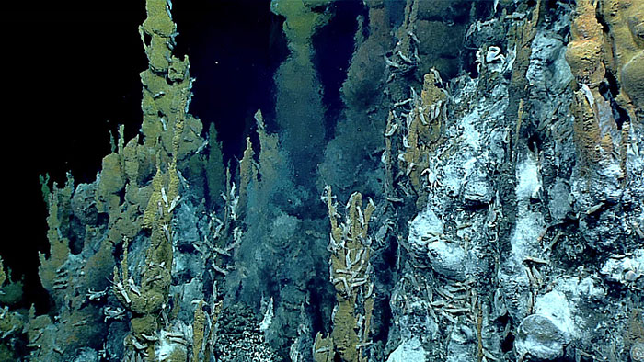

**Synopsis:** Explorationof a number of significant chimneys/black smokers.

**Prognosis for Reconstruction:** These impressive structures are an ideal candidate for 3D reconstruction as they have good relief and texture; and are large compared to the field of view of the ROV, making a synthetic overview image/reconstruction highly useful for metrology as well as for public interest.

The relatively high energetics around a chimney create a number of problems for reconstruction. Visible “smoke,” Schlieren from high temperature vents, large numbers of macrofauna, and high levels of bacterial floc suspended in the water column are all confounding elements for effective frame-to-frame image matching. At this point it is unclear whether this will result in reconstruction failure within *Photoscan*, model inaccuracy, or if the matching system is tolerant to these distortions.

At a higher level, it remains to be seen if active mitigation can reduce the impact of these distortions, either by masking out areas of significant distortion, or through some more complex compensation. The bright white bacterial mats seen on some chimneys may also be an impediment as camera saturation can be seen in some of the imagery, particularly from the supplemental cameras.

**Leg 3, Dive 4 (EX1605L3_DIVE04), June 21st 2016:** Hadal Ridge

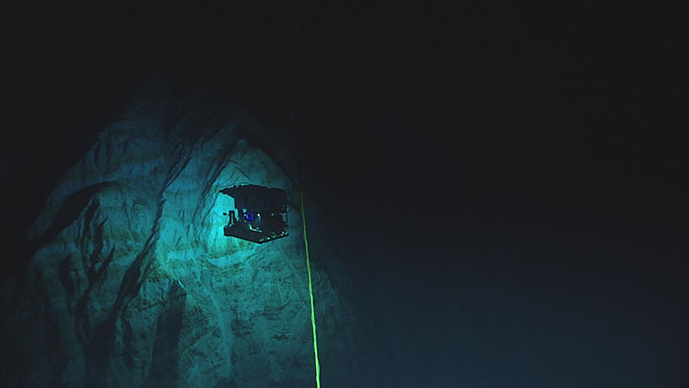 

**Synopsis:** Dive started at D2 ROV maximum depth of ~6000m and explored local geology. In contrast with EX1605L1_DIVE11, this dive features relatively optically clear water and multiple “long vistas” over significant topography, including areas of interesting geologic layering.

**Prognosis for Reconstruction:**  This data presents a good test case for the use of 3D reconstruction over very large (landscape) scales, particularly for topographic visualization and mapping. Regions of well-lit, relatively static rock fields (above right) should be highly suitable for small-scale reconstruction, assuming sufficient motion parallax. It remains to be seen if this relatively small-domain reconstruction will scale out to larger extents without either processing scale issues or the introduction of gross spatial distortions. The latter is of concern because the SOP for the ROV does not typically include loop closures as would be necessary for minimizing accumulated errors. However, we have not reviewed the entirety of the video sequence and have not verified if there are loop closures in this dive.

Given the scope of the landscape features, this would be a particularly interesting data set for cross-correlation of the ROV and Serios video footage (above left).

**Leg 3, Dive 7 (EX1605L3_DIVE07), June 24th 2016:** Chamorro Seamount

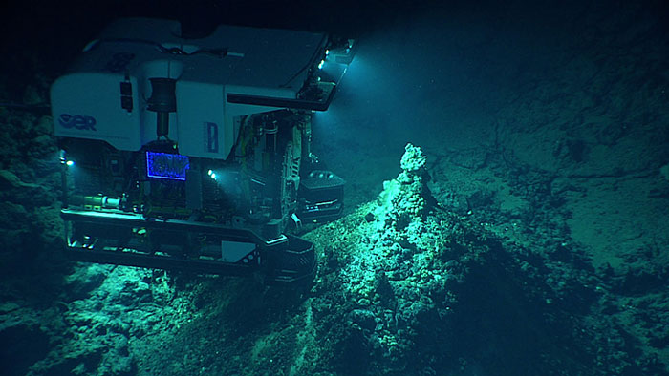 

**Synopsis:** Up-slope transect of Chamorro Seamount, including regions of highly textured geology and small thermal structures.

**Prognosis for Reconstruction:** This dive presents both opportunities for reconstruction of small targets e.g., chimneys (above left) as well as using reconstruction for more broad-area mapping as the ROV transits over the geology. The reconstruction of small chimneys should provide an interesting science test case: the reconstruction can almost certainly be done, but does it provide additional value? With the larger chimneys, the prospect of a synoptic view of a 20-30m chimney is enticing as a visual artifact.

**Leg 3, Dive 22 (EX1605L3_DIVE22), July 8-9 2016:** Romeo and Juliet

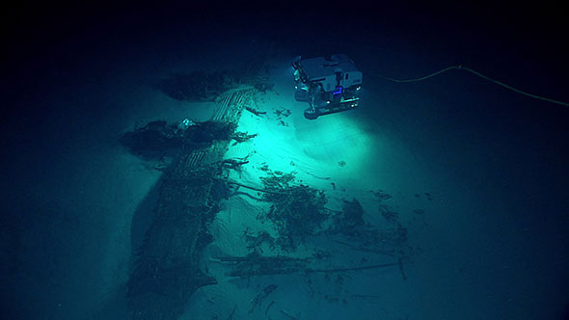 

**Synopsis:** Investigation of sonar targets suspected to be aircraft wreckage.

**Prognosis for Reconstruction:** Besides the archaeological interest, it is generally presumed that anthropogenic objects are more suitable for reconstruction (more suitable “texture”) although that is generally not proven. The varied wreckage found in this sequence should be highly suitable for reconstruction as individual elements, as well as generation of large-scale maps of debris . Because the individual debris sites are relatively small and the ROV spent long periods of careful investigation of each, the possibility of collecting multiple loop closures is higher than in the earlier transect missions, increasing the probability of successful map generation.

The optically clear water and the relatively flat topography again raises the probability of using the Serios overview video to assist with broad-scale image stitching. Due to the archeological protocols in use, this video also contains many views of objects at multiple scales. Our current emphasis is on reconstruction at the broadest scale possible, but the ability to use high-zoom detailed imagery to enhance a reconstruction is an intriguing possibility.

Work Progress and Plan:

Within this first six months of the award, time was shared with other ongoing projects, resulting in a relatively low spend on this project, as reflected in the budget.

Having developed tools and procedures for indexing within dives, a number of video sequences of particular interest will be identified and reconstructed using both the commercial *Photoscan* tool and the realtime photometric packages under development at UW-APL.

Expenditures:

Project expenses through 27 February 2017:

Salaries:  $1417.94  
Benefits: $785.03  
Supplies: $1041.98  
APL PDC: $1031.94  
F&A: $812.62  
TOTAL: $5089.51

Expenditures within this time period included purchase of data storage for transfer from OER Data Management and for local processing and, and salary for the PI.